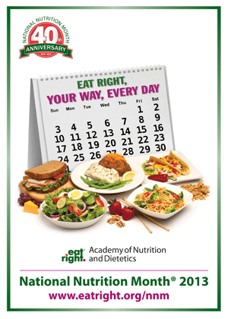
A Health Professional’s Abridged Resource Guide to National Nutrition Month

With March just around the corner, it is that time of year again to celebrate and promote healthy eating and nutrition. As Health Professionals, planning for National Nutrition Month can be time-consuming and finding teaching resources tedious at times. This guide serves as an easy way to locate credible resources for every age group.
The 2013 Theme: Eat right, your way, every day
Translation: A person’s eating habits are impacted by food preferences, lifestyle, cultural & ethnic traditions, and health concerns. Therefore, the theme promotes personalized healthy eating that is specific for each individual.
Resources:

Elementary Aged Children | Young Adults | Adults
Kids Word Search | 10 Steps to Healthy Eating  (fill in the blank) | Adult Soduku
Draw your Healthy Plate | Whole Grain Scramble | 20 Ways to Enjoy more Fruits and Vegetables
Berry Tales Activity | Healthy Meals on the Run | Healthy Options Away from Home
Serving Up MyPlate | Nutrition Voyage Activities

